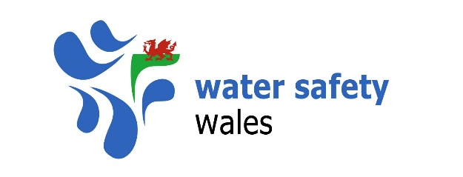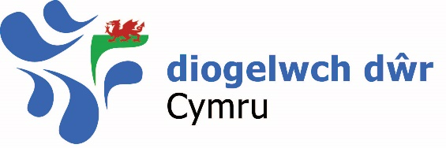

Terms of Reference

Water Safety Wales

Document History

Approval by Water Safety Wales Steering Group:

Date | Version
1.05.20 | 1
1.05.21 | 2

Terms of Reference

Name of Group

Water Safety Wales

Background

The group was established in 2017 as the All Wales Water Safety Forum by a group of organisations working on water safety and drowning prevention in Wales. In 2018 the group was renamed Water Safety Wales.

Purpose:

Water Safety Wales brings together organisations in Wales with an interest in water safety and downing prevention. It aims to:

- Promote a consistent and common approach to water safety
- Promote drowning prevention and water safety education and awareness to the communities its members serve
- Work in a collaborative multi-agency approach to identify and target harden areas of risk
- Develop and implement Wales’ Drowning Prevention Strategy 2020-26

Structure

All Water Safety Wales members sit on the Main Group. This group meets four times a year. Main Group Meetings provide members with the opportunity to share data and knowledge, review incidents of note, share best practice, present ideas and initiatives and give updates on their work.

Main meetings will also be used to progress and review the delivery of Wales’ Drowning Prevention Strategy 2020-26

Subgroups may be formed to focus on a specific area or take forward specific projects or objectives. These subgroups would be open to all members to join, subject to approval by the Steering Group.

The Steering Group oversees the Main Group and any subgroups. The Steering Group is made up of the Chair, two Vice Chairs and two Steering Group Members.

Membership:

Each organisation shall be represented by a nominated representative who shall have responsibility to contribute to Water Safety Wales and the delivery of Wales’ Drowning Prevention Strategy 2020-26.

Any invites to potential new members should be approved by the Steering Group.

An organisation must attend at least one meeting per year to retain Water Safety Wales membership. A record of attendance will be kept by the Steering Group. The Steering Group will contact members who have not attended at least one meeting in 12 months to discuss their future membership.

Members unable to attend Main Group meetings can submit updates to the Steering Group to be shared at Main Group meetings.

Any member can invite a non-member to attend a Main Group meeting. These invites should be approved by the Steering Group.

No more than two guests of one organisation can attend a Main Group meeting, without the prior consent of the Steering Group.

If a member wishes to leave Water Safety Wales, they should notify the Steering Group.

All Water Safety Wales members must follow the terms as set out in the following documents:

- Terms of Reference
- Roles and Responsibilities

Water Safety Wales will agree a memorandum of understanding with partner agencies and individuals where the Steering Group deem it necessary.

Water Safety Wales has a memorandum of understanding with the National Water Safety Forum. Water Safety Wales is represented on the Co-ordinating Group of National Water Safety Forum by the Chair, or a deputy, and supports the UK Drowning Prevention Strategy.

Brand

Water Safety Wales members are asked to support the promotion of the Water Safety Wales brand.

Any member using the Water Safety Wales logo and/or brand in publications or printing must ensure its use in keeping with the spirit and objectives of Water Safety Wales and Wales’ Drowning Prevention Strategy 2020-2026. This can be done by informing the Steering Group in advance.

All press releases or other media publications using the Water Safety Wales logo and/or brand must be agreed by the Steering Group in advance.

Meetings

The Main Group will meet four times a year in January, April, July and October. Minutes for all Main Group meetings will be made available to all members.

Items for inclusion on Main Group meeting agendas should be sent to the Steering Group 21 days in advance of the meetings. Agendas for Main Group meetings and any accompanying papers will be sent out to all members at least 14 7 days in advance.

All agendas should follow a consistent framework including:

- Welcome
- Minutes from previous meetings, accuracy and matters arising
- Wales’ Drowning Prevention Strategy 2020-26 update
- Review of incidents of note
- Update from Subgroup chairs
- Partner updates
- AOB
- Date and Time of next meeting

If the Chair is unable to attend a Main Group meeting, one of the Vice Chairs will deputise.

Internal Communications

If a member wishes to share information with the whole group, it should go through the Steering Group.

All Water Safety Wales emails and other correspondence must go through the Steering Group.

External Representation

Representation of Water Safety Wales to external organisations and partners should be approved by the Steering Group. The Chair is the main representative of Water Safety Wales to external organisations and partners. The Chair may delegate external representation to other members of the Steering Group or the Main Group, subject to approval by the Steering Group.

Activity between any Water Safety Wales member and an external organisation or partner should be reported into the Steering Group if they are representing Water Safety Wales in that activity.

Voting

Where decisions of Water Safety Wales are made by a vote, one vote will be allowed by each member. The Chair would have the casting vote.

Complaints or grievances

Any member who has a complaint or grievance about any aspect of Water Safety Wales should submit it to the Steering Group, who will investigate and respond.

If a grievance or complaint is raised about the Chair and/or any if the Vice Chairs, the other members of the Steering Group will investigate the matter and take an appropriate action. The member under investigation can be present during the investigation along with a representative from their organisation.

If a grievance or complaint is raised about a member of the Main Group of Water Safety Wales, the Steering Group will investigate the matter and take an appropriate action. The member under investigation can be present during the investigation along with another representative from their organisation or other independent person.

Finances

Water Safety Wales does not hold any finances and does not have a bank account.

Any correspondence or queries about finance should be submitted to the Steering Group through the Chair.

Data Access

Any WAID data used by Water Safety Wales will be approved by the National Water Safety Forum.

Review

These Terms of Reference will be subject to a review annually.

Changes can be made to sections of the Terms of Reference between full reviews as necessary, subject to approval by the Steering Group. Suggestions for changes between full reviews should be submitted to the Steering Group for consideration.

